

ASSET VERIFICATION AND RECORDING TOOL KIT


Plot 31, Bukoto Street
P.O Box 7657, Kampala, Uganda
+256 (0) 39 2000216/0772525235
email: cpa@cpa.ug

www.cpa.com

August to September 2026

VERIFICATION DETAILS

NAME OF THE REGION: | NORTHERN UGANDA
SUB-REGION: | LANGO SUB-REGION
Name of Local Government | ALEBTONG DISTRICT LOCAL GOVERNMENT
VERIFIER PARTICULARS
Full name | AGANYO MERCY
Contact/ email and Telephone | 0786551826  mercyaganyo22@gmail.com
Supervisor/ Sub team leader
Name | MR. DENIS
Contact | 0779622063
Date of submission | 25TH AUGUST, 2026

HEALTH CENTRES
INFORMANT INTERVIEW/DISCUSSION GUIDE (INCHARGE OR RESPONSIBLE PERSON)

Name of Health Centre: AWEI HEALTH CENTRE III

1a | Does the Facility have a record of all assets provided under UgIFT.  (Obtain a record and verify if it has the costs and numbers supplied | YES
1b | If Not ask how many were supplied and when.

2 | How does this facility Maintain (repair/service/replace) the assets provided under Ugift

In case of any damage, Awei Health Centre III uses 10% of the Primary Health Care Fund (PHC) to repair and service the damages.

3 | Does the facility take regular record about functionality/ or breakdown of the assets provided?

Awei Health Centre tags the responsibility on the staff who are on duty to keep them well. The equipment in the store are kept safely by the store keeper who records all the equipment provided.

4 | How has the UgIFT support helped in service delivery in the area, any issues, challenges and any recommendations for better program implementation.

The assets provided have helped in improving the lives of the locals.

There is no power in the Out Patient Department (OPD), Some equipment are still kept in the store because the laboratory and the general wards are too small to accommodate all the equipment provided.
They lack well trained staff to work on the machines like the instrument Set Basic, ENT

Recommendations: UGIFT should help Awei Health Center III to train its staff in order equip them with the relevant skills to operate the machines.

PROCEED TO VERIFICATION AFTER THIS DISCUSSION

Health centre checklist

NAME OF LG ALEBTONG DISTRICT LOCAL GOVERNMENT, NAME OF HEALTH FACILITY AWEI HEALTH CENTRE III

Equipment/ Item | Department | Asset Number | Item  Description | Life in Months | Tag Number ( engrave no.) | Date Of Purchase | Date Placed In Service | Recoverable cost | Cost | Acc Dep Cost | Net Book Value | Ytd Deprn | Equipment status | Remarks
B.P. Machine, Digital (2) | MCH  OPD |  | Digital | 60 | Not engraved | 27th May 2025 | October 2025 |  | 300000 |  |  |  | Functional | Good condition
B.P. Machine (Aneroid wall mounted) (2) | MCH  STORE |  | Manual | 60 | Not engraved | 27th May 2025 | October 2025 |  | 700000 |  |  |  | 1is functional | Good working condition and 1 is still in the store.
Autoclave 20 Liters.,Duo Operated | ………. | …….. | ………. | ……….. | ………… | ………. | ………. | ………. | …………. | …… | …….. | ……… | ……….. | …….
Bowl, Kick (1) | Health |  | Manual | 60 | Not engraved | 27th May 2025 | October 2025 |  | 180000 |  |  |  | Non-functional | Still in the store.
Bowl Stand | Health |  | Metallic | 60 | Not engraved | 27th May 2025 | October 2025 |  |  |  |  |  | Non-functional | Still in the store
Counting chamber Neubauer- Improved(2) | LAB  STORE |  | Plastic | 60 | Not engraved | 27th May 2025 | October 2025 |  |  |  |  |  | Functional | Good working condition and 1 is still in the store
Cupboard Steel, Lockable (2) | OPD  MCH |  | Metallic | 60 | Not engraved | 27th May 2025 | October 2025 |  |  |  |  |  | Functional | Good working condition.
Drip Stand (8) | General ward  MCH |  | Metallic | 70 | Not engraved | 27th May 2025 | October 2025 |  |  |  |  |  | Functional | Good working condition.
ESR Stand (1) | Health |  | Plastic | 60 | Not engraved | 27th May 2025 | October 2025 |  |  |  |  |  | Non-functional | Still in the store.
Examination Couch (2) | OPD  MCH |  | Metallic and cushion | 60 | Not engraved | 27th may 2025 | October 2025 |  |  |  |  |  | Functional | Good working condition.
Examination light,LED (2) | OPD  MCH |  | Plastic | 60 | Not engraved | 27th May 2025 | October 2025 |  |  |  |  |  | Functional | Good condition.
Glucometer (2) | LAB  MCH |  | Plastic | 50 | Not engraved | 27th May 2025 | October 2025 |  | 400000 |  |  |  | Functional | Good working condition.
Haemoglobin Meter, Digital (2) | STORE |  | Digital and plastic | 50 |  | 27th May 2025 | October 2025 |  | 700000 |  |  |  | Non-functional | Still in the store because there are others in use
Height Meter(1) | STORE |  | Metallic | 60 | Not engraved | 27th May 2025 | October 2025 |  |  |  |  |  | Non-functional | Still in the store
Instrument Trolley (2) | MCH  WARD |  | Movable metallic | 50 | Not engraved | 27th May 2025 | October 2025 |  |  |  |  |  | Functional | Good working condition.
Microscope Binocular (1) | STORE |  | Metallic | 60 | Not engraved | 27th May 2025 | October 2025 |  | 2800000 |  |  |  | Non-functional | Still in the store because it is sub-standard and does not see objects clearly
Otoscope (1) | IPD |  | Metallic | 40 | Not engraved | 27th May 2025 | October 2025 |  |  |  |  |  | Functional | Good condition.
Patient Screen (4) | MCH  IPD  GENERAL WARD |  | Movable metallic | 50 | Not engraved | 27th May 2025 | October 2025 |  |  |  |  |  | Functional | Good condition.
Patient Trolley (1) | IPD |  | Movable metallic | 40 | Not engraved | 27th May 2025 | October 2025 |  | 2200000 |  |  |  | Functional | Good working condition
Refrigerator, Basic (1) | LAB |  | Metallic | 80 | Not engraved | 27th May 2025 | October 2025 |  | 1800000 |  |  |  | Functional | Good condition.
Stethoscope (4) | MCH  OPD |  | Metallic and digital | 70 | Not engraved | 27th may 2025 | October 2025 |  | 360000 |  |  |  | Functional | Good condition and 2 are in the store
Stop Watch (2) | STORE |  | Plastic | 60 | Not engraved | 27th May 2025 | October 2025 |  |  |  |  |  | Non-functional | Still in the store.
Stretcher (1) | IPD |  | Metallic with leather | 70 | Not engraved | 27th May 2025 | October 2025 |  |  |  |  |  | Functional | Good condition.
Stove, Gas (1|) | IPD |  | Metallic | 60 | Not engraved | 27th May 2025 | October 2025 |  | 750000 |  |  |  | Functional | Good condition.
Weighing Scale with Height Meter, Adult (2) | OPD  MCH |  | Use battery | 60 | Not engraved | 27th May 2025 | October 2025 |  |  |  |  |  | Functional | Good working condition.
Weighing Scale, Infant (2) | MCH |  | Plastic and use battery | 40 | Not engraved | 27th May 2025 | October 2025 |  |  |  |  |  | Functional and 1 is non-functional | Good working condition and 1 is still in the store.
Weighing Scale, Toddler (2) | MCH |  | Plastic | 50 | Not engraved | 27th May 2025 | October 2025 |  | 1000000 |  |  |  | Functional | Good condition.
Wheel Chair (1) | IPD |  | Metallic with leather | 60 | Not engraved | 27th May 2025 | October 2025 |  |  |  |  |  | Functional | Good working condition.
Audio Visual Equipment | ….. | …….. | ……. | ……. | ……. | …….. | ……… | ……… | ……… | …….. | .. | …….. | ……. | ……
Medical Waste Bin (6) | Store |  | Plastic | 50 | Not engraved | 27th May 2025 | October 2025 |  |  |  |  |  | Non-functional | Still in the store.
Wall Clock (4) | MCH  IPD |  | Plastic | 40 | Not engraved | 27th May 2025 | October 2025 |  |  |  |  |  | Functional | 2 are in a good condition and 2 are still in the store.
Diagnostic Equipment Set for MCH (2) | MCH |  | Metallic | 60 | Not engraved | 27th May 2025 | October 2025 |  | 2400000 |  |  |  | Functional | Good condition and 1 is still in the store
Diagnostic Equipment Set for OPD (2) | Store |  | Metallic | 60 | Not engraved | 27th May 2025 | October 2025 |  |  |  |  |  | Non-functional | Still in the store because some are in use
Glassware Set, Laboratory, Basic (2) | Store |  | Glass in nature | 70 | Not engraved | 27th May 2025 | October 2025 |  |  |  |  |  | Non-functional | Still in store.
Hollow Ware Set, Treatment (3) | Store |  | Stainless steel | 70 | Not engraved | 27th May 2025 | October 2025 |  |  |  |  |  | Non-functional | Still in the store.
Instrument Set, Dressing (3) | IPD |  | Stainless steel | 60 | Not engraved | 27th May 2025 | October 2025 |  |  |  |  |  | Functional | Good condition and 2 are still in store
Instrument Set, Basic ENT (3) | Store |  | Stainless steel | 40 | Not engraved | 27th May 2025 | October 2025 |  |  |  |  |  | Non-functional | Still in store because others are still in the store
Instrument Set, Suture | ……. | …….. | …… | …… | …… | …… | …… | …… | ……. | …… | …… | …… | ……… | ……
Pulse Oximeter, Hand held (2) | Store |  | Digital | 50 | Not engraved | 27th May 2025 | October 2025 |  |  |  |  |  | Non-functional | Still in store because others are in use
Bed, Adult Patient with Mattress (10) | IPD  MCH |  | Metallic with mattress | 60 | Not engraved | 27th May 2025 | October 2025 |  |  |  |  |  | Functional | Good working condition and 4 are still in the store
Bed, Pediatric Patient, With Mattress (2) | MCH |  | Metallic with mattress | 60 | Not engraved | 27th May 2025 | October 2025 |  |  |  |  |  | Functional | Good condition
Bedside Locker | … | ….. | …… | …… | …… | ……. | …… | ……. | ……. | …… | ….. | ….. | ….. | …..
Cupboard, Instrument (1) | Store |  | Metallic | 60 | Not engraved | 27th May 2025 | October 2025 |  |  |  |  |  | Non-Functional | Still in the store.
Delivery Bed, Hydraulic manual (1) | MCH |  | Metallic with mattress | 70 | Not engraved | 27th May 2025 | October 2025 |  |  |  |  |  | Functional | Good condition.
Oxygen Therapy Apparatus, Mininum 45L cylinder (2) | MCH  Store |  | Plastic in nature | 60 | Not engraved | 27th May 2025 | October 2025 |  |  |  |  |  | Functional | Good condition and 1 is still in the store
Resuscitator Manual, Infant, with all Mask sizes (2) | Store |  | Plastic | 60 | Not engraved | 27th May 2025 | October 2025 |  |  |  |  |  | Non-functional | Still kept in the store.
Resuscitator Manual, Adult, with all mask sizes (2) | MCH |  | Plastic | 60 | Not engraved | 27th May 2025 | October 2025 |  |  |  |  |  | Functional | Good condition and 1 is still in the store
Suction Apparatus, (Electric)(2) | Store |  | Electrical in nature | 70 | Not engraved | 27th May 2025 | October 2025 |  | 3,000,000 |  |  |  | Non-Functional | Still in the store because there is no power
Nebulizer, Ultrasonic (1) | Store |  | Plastic | 70 | Not engraved | 27th may 2025 | October 2025 |  | 650,000 |  |  |  | Non-functional | Still in the store because there is no power
Oxygen Concentrator, Duo Flow (4) | MCH  IPD |  | Electrical in nature | 80 | Not engraved | 27th May 2025 | October 2025 |  |  |  |  |  | Functional | Good condition and 2 are still in the store.
Bench (4) | IPD |  | Wooden with metallic stands | 90 | Not engraved | 27th May 2025 | October 2025 |  |  |  |  |  | Functional | Good condition
Disinfection Buckets (6) | MCH |  | Plastic | 60 | Not engraved | 27th May 2025 | October 2025 |  |  |  |  |  | Functional | Good condition
Baby Cot (5) | MCH |  | Plastic | 90 | Not engraved | 27th May 2025 | October 2025 |  |  |  |  |  | Functional | Good condition and 4 are still kept in the store
Diagnostic Equipment Set for Ward (3) | IPD |  | Metallic and plastic | 90 | Not engraved | 27th May 2025 | October 2025 |  |  |  |  |  | Functional | Good condition and 2 are still store
Hollow Ware Set, Ward (3) | Store |  | Stainless steel | 60 | Not engraved | 27th may 2025 | October 2025 |  |  |  |  |  | Non-functional | Still in the store
Instrument Set, Delivery (3) | MCH |  | Stainless steel | 60 | Not engraved | 27th May 2025 | October 2025 |  |  |  |  |  | Functional | Good condition and 2 are still in store
Instrument Set, Stitch Removing (3) | IPD |  | Stainless steel | 60 | Not engraved | 27th May 2025 | October 2025 |  |  |  |  |  | Functional | Good condition and 2 are still in store.
MVA Kit (4) | Store |  | Plastic | 60 | Not engraved | 27th May 2025 | October 2025 |  |  |  |  |  | Non-functional | Still in store
Stool, Laboratory 1 | LAB |  | Metallic | 60 | Not engraved | 27th May 2025 | October 2025 |  |  |  |  |  | Functional | Good condition
Penguin Sucker (3) | MCH  Store |  | Rubber in nature | 70 | Not engraved | 27th May 2025 | October 2025 |  |  |  |  |  | Functional | Good condition and 2 are still in store.
Fetoscope, Dopplar (2) | MCH  Store |  | Manual | 60 | Not engraved | 27th May 2025 | October 2025 |  |  |  |  |  | Functional | Good condition and 1 is in store
Bubble CPAP (2) | Store |  | Plastic | 90 | Not engraved | 27TH May 2025 | October 2025 |  |  | . | …… | ……. | Non-functional | Still kept in store.
Centrifuge (Electric) (2) | Store |  | Electrical in nature | 80 | Not engraved | 27th May 2025 | October 2025 |  |  |  |  |  | Non-functional | Still in the store because there is no power
Kangaroo Mother Care Chair (1) | MCH |  | Metallic with leather | 60 | Not engraved | 27th May 2025 | October 2025 |  |  |  |  |  | Functional | Good condition
Radiant Infant Warmer | …. | …… | ……. | …… | ……. | ……. | …….. | ……. | …….. | …….. | ……. | …….. | …… | …….
Haemoglobin Meter, Sahli | …. | …… | ……. | ……. | …….. | ……… | ……. | …….. | ……… | ……… | …… | ……. | …….. | ……
Delivery Bed (1) | MCH |  | Metallic with mattress | 90 | Not engraved | 27th May 2025 | October 2025 |  |  |  |  |  | Functional | Good condition
Examination light (2) | IPD |  | Manual | 70 | Not engraved | 27th May 2025 | October 2025 |  |  |  |  |  | Functional | Good condition
Instrument set, ENT Basic for HCIII (3) | Store |  | Steel | 60 | Not engraved because ther | 27th May 2025 | October 2025 |  |  |  |  |  | Non-functional | Still in store because there are others in use
Bag Valve mask (Ambu Bag), Neonatal | …. | …… | ……. | ……. | ……. | …… | ……. | …… | ….. | …… | ……. | …….. | …….. | …….
Incubator | ……. | …… | …….. | …….. | ……… | ………. | ……… | ……… | ………. | ……… | ………. | ……. | …… | ……..
Office Chair (4) | MCH  OPD |  | Metallic with leather | 90 | Not engraved | 27th May 2025 | October 2025 |  |  |  |  |  | Functional | Good condition
Desk | …… | ……. | …… | …… | ……. | ….. | ……. | …….. | …….. | ……. | ……. | ……. | …….. | ……
Filing Cabinet (2) | OPD  HIV Clinic |  | Metallic | 60 | Not engraved | 27th May 2025 | October 2025 |  |  |  |  |  | Functional | Good condition
Non Residential Buildings | …… | …… | ……. | ……. | …….. | ……. | …….. | …… | ….. | ….. | ….. | …… | …… | ……
Residential Buildings (2) Twin house and MCH ward | Health |  | Block concrete building | 299 | Not engraved | 27th May 2025 | October 2025 |  |  |  |  |  | Functional | Good condition

SCHOOL VERIFICATION CHECKLIST

SCHOOL INTERVIEW/DISCUSSION GUIDE

Name of school: ………………………………………………………………………………..

1a | Does the Facility have a record of all assets provided under UgIFT.  (Obtain a record and verify if it has the costs and numbers supplied
1b | If Not ask how many were supplied and when.

2 | How does this facility Maintain (repair/service/replace) the assets provided under Ugift

3 | Does the facility take regular record about functionality/ or breakdown of the assets provided?  Nonfunctional/ working, and reasons for non-functionality.

4 | How has the UgIFT support helped in service delivery in the area, any issues, challenges and any recommendations for better program implementation.

PROCEED TO VERIFICATION AFTER THIS DISCUSSION

SCHOOL FURNITURE
(School Desks, Office chairs, Laboratory stools, Book shelves)

Name of LG………………………………………………………………… Name of SCHOOL………………………………………………………………………………

Equipment/ Item | Department | Asset Number | Item  Description | Life in Months | Tag Number ( engrave no.) | Date Of Pur | Date Placed In Service | Recoverable cost | Cost | Acc Dep Cost | Net Book Value | Ytd Deprn | Equipment status | Remarks

ICT ITEMS TO VERIFY
(Desktop Computer, Server Processor, Network Switch 24 Port, Multipurpose Printer, UPS, Projector, Air Conditioners, Server, CCTV Camera)

Name of LG…………………………………………………………………………… Name of SCHOOL………………………….………………………………………

Equipment/ Item | Department | Asset Number | Item  Description | Life in Months | Tag Number ( engrave no.) | Date Of Pur | Date Placed In Service | Recoverable cost | Cost | Acc Dep Cost | Net Book Value | Ytd Deprn | Equipment status | Remarks

BUILDINGS TO VERIFY
(Non- Residential and Residential, Kitchen, Toilets/Pit latrine Water tanks, Fences etc.)

Name of LG…………………………………………………………………………… Name of SCHOOL………………………….………………………………………

Equipment/ Item | Department | Asset Number | Item  Description | Life in Months | Tag Number ( engrave no.) | Date Of Pur | Date Placed In Service | Recoverable cost | Cost | Acc Dep Cost | Net Book Value | Ytd Deprn | Equipment status | Remarks

SAMPLE PICTURES OF AWEI H/C III
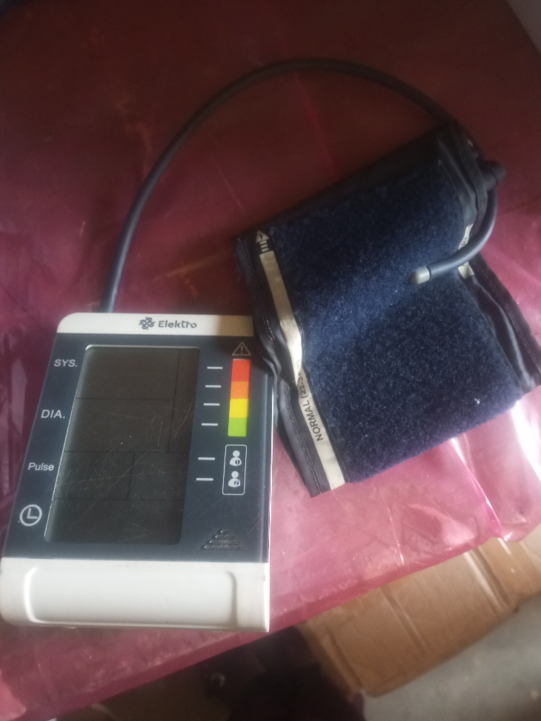

BP Machine Manual

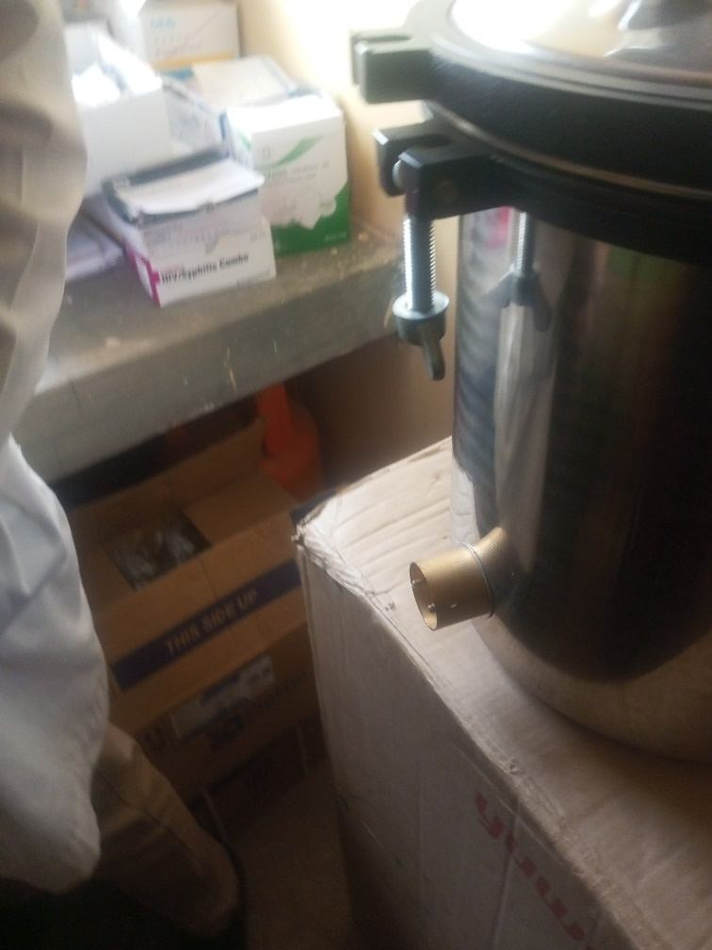

Autoclave

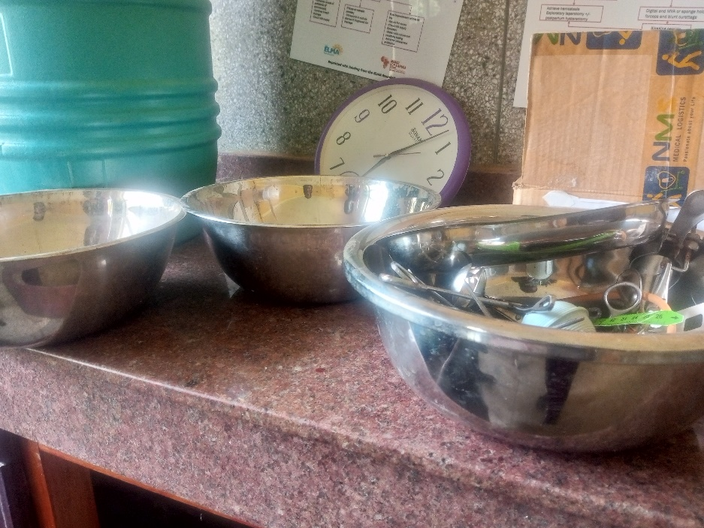

Equipment Set

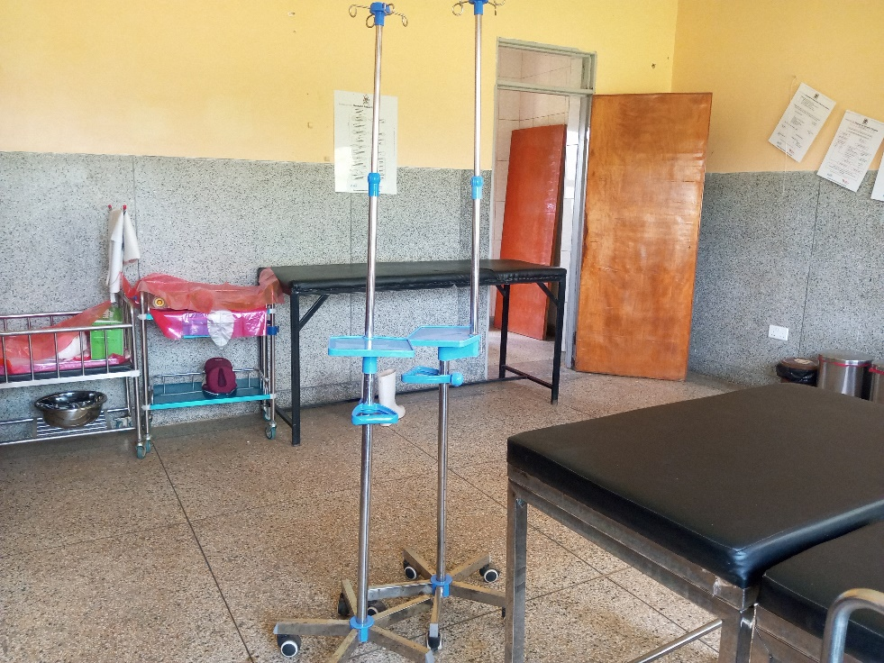

Drip Stand and Patient Trolley

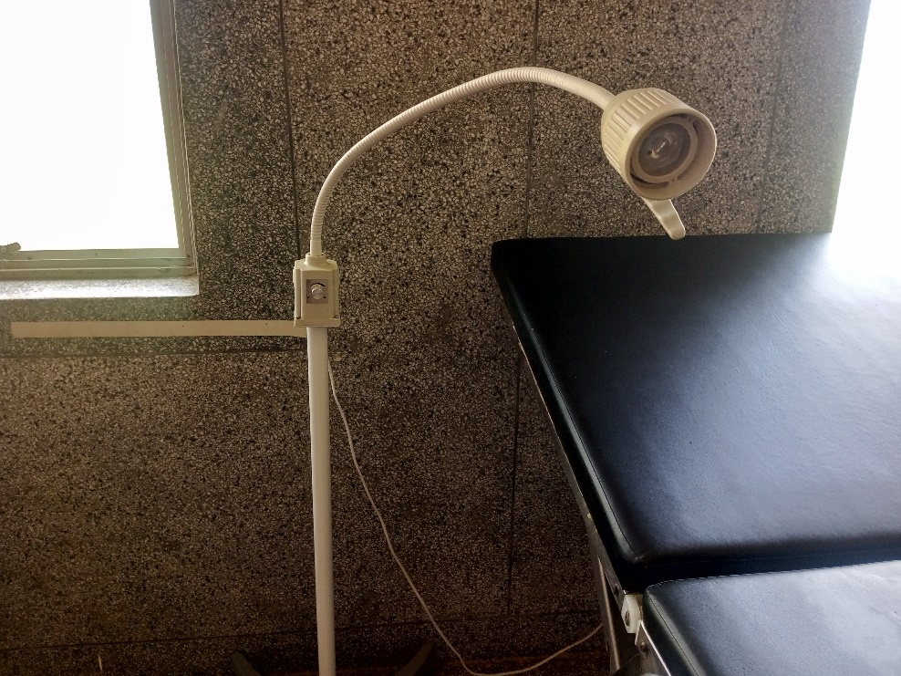

Examination Light LED

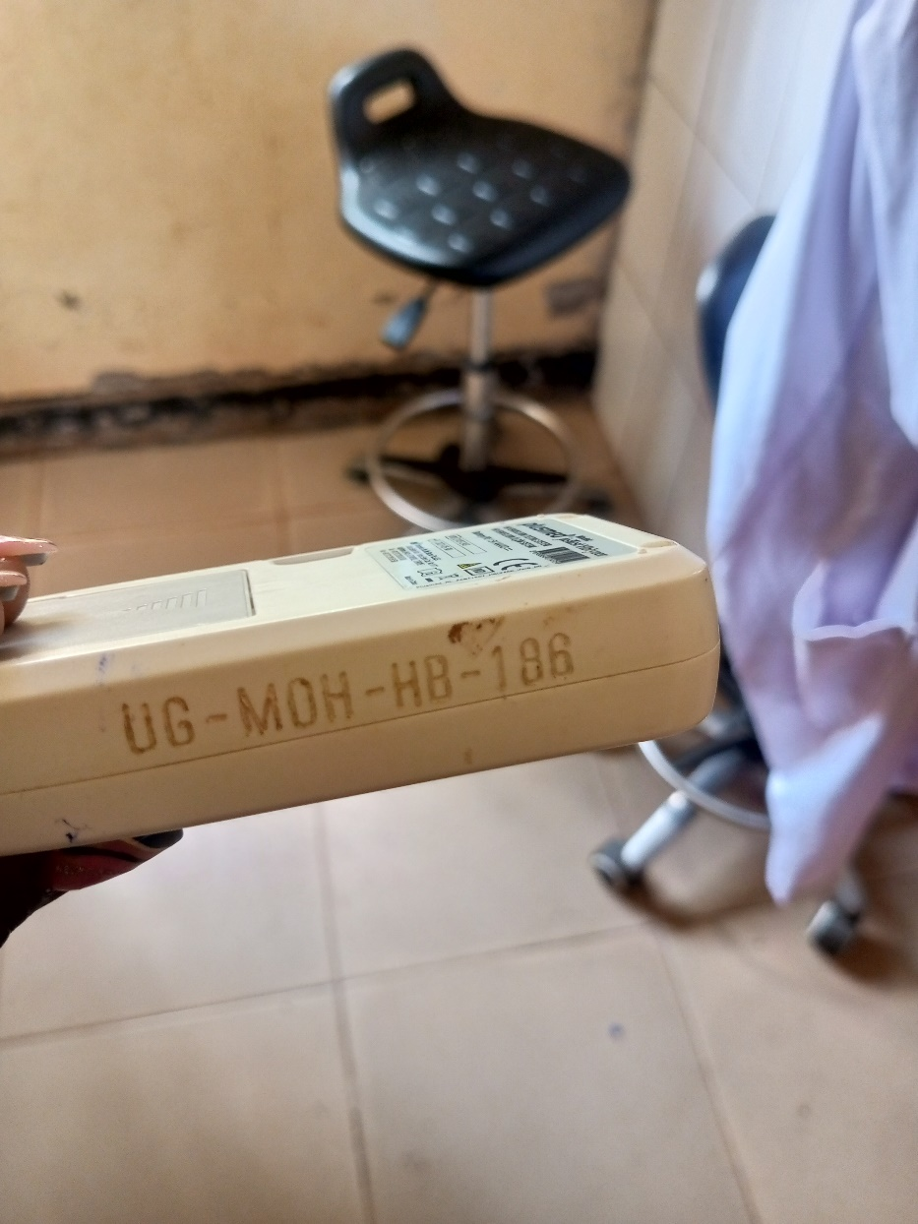

Glucometer and Laboratory Stool

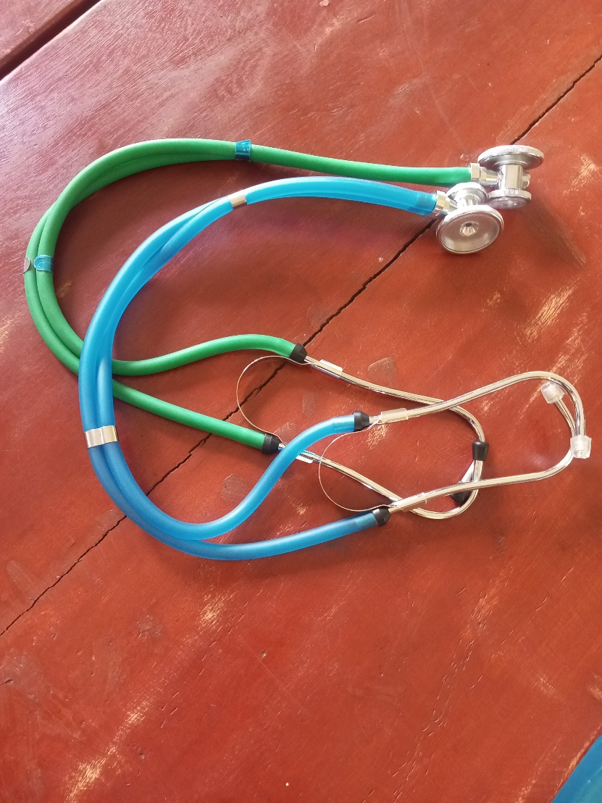

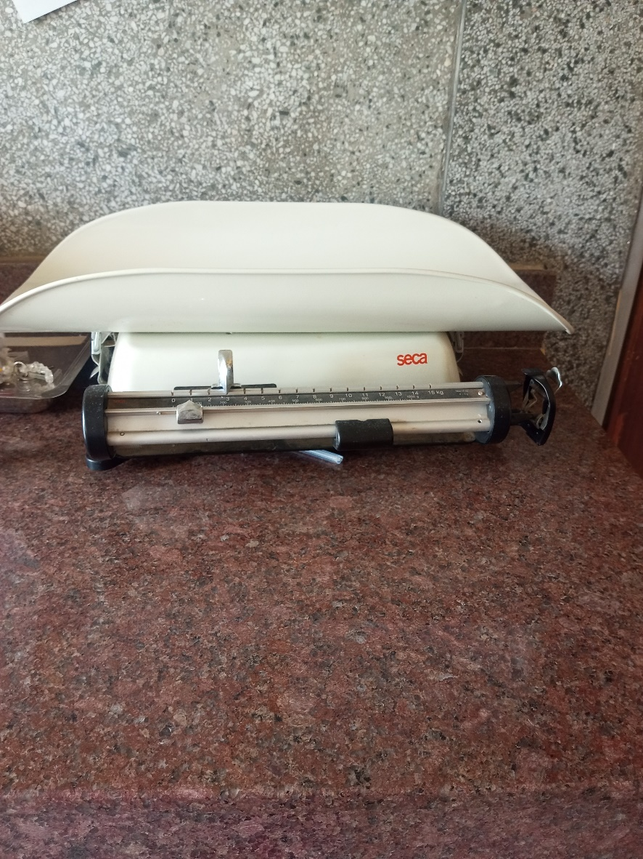

Weighing Scale Infant

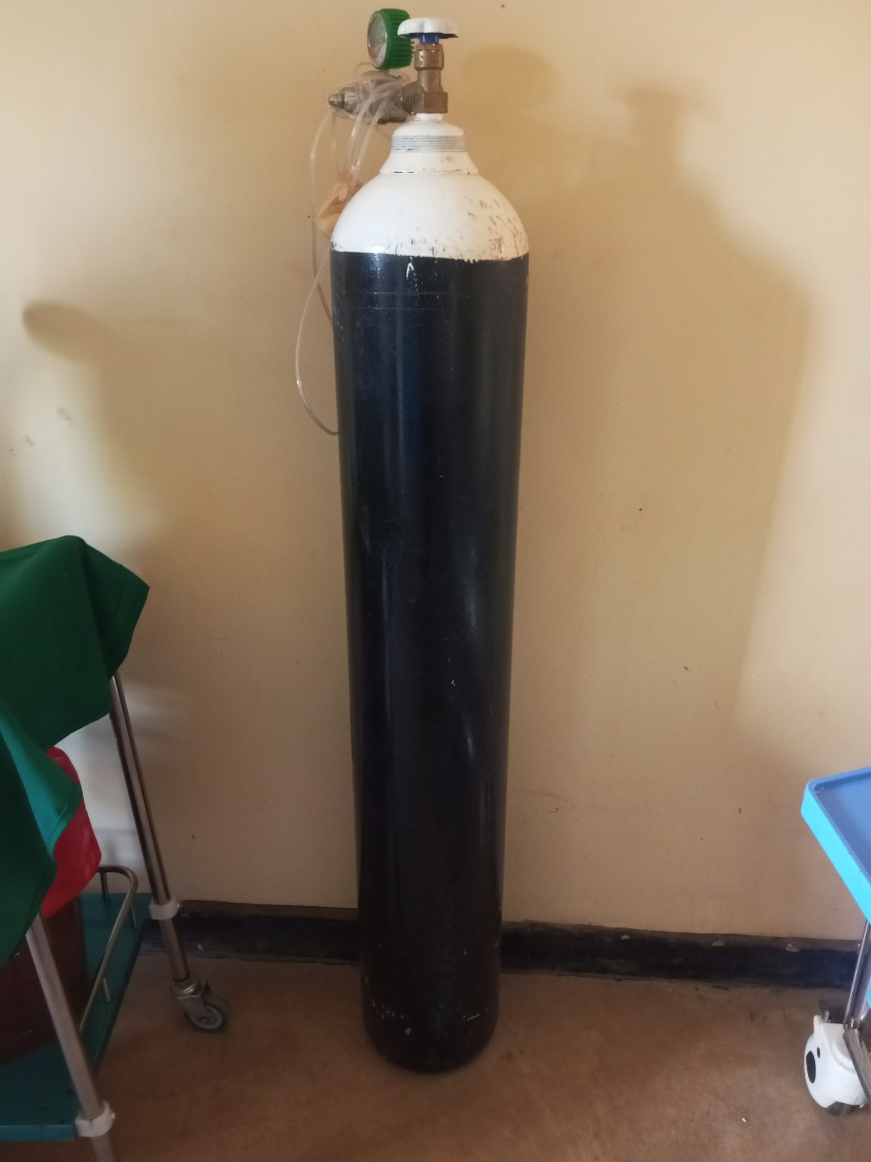

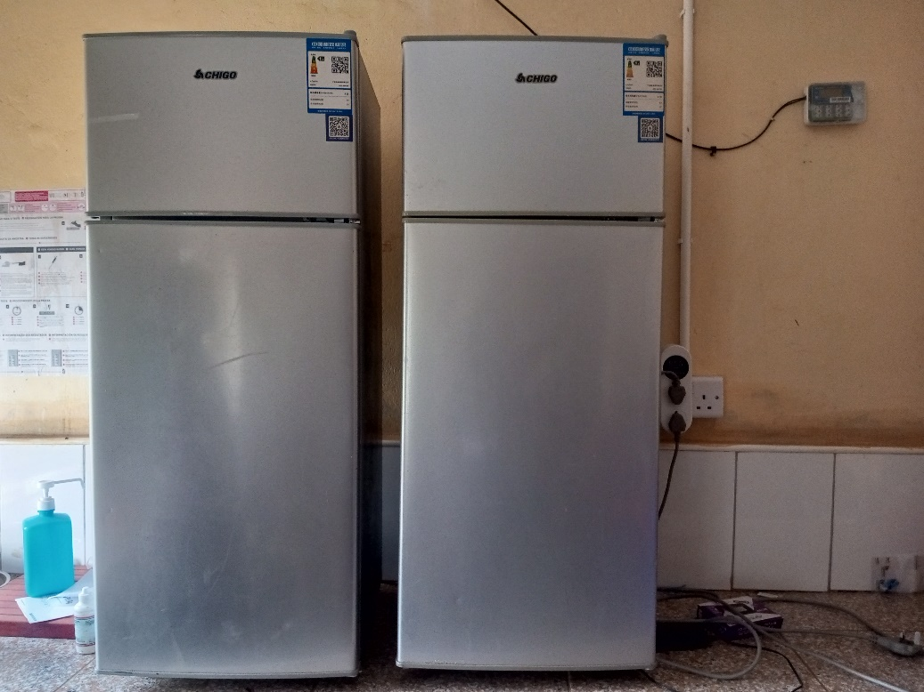

Refrigerator Basic

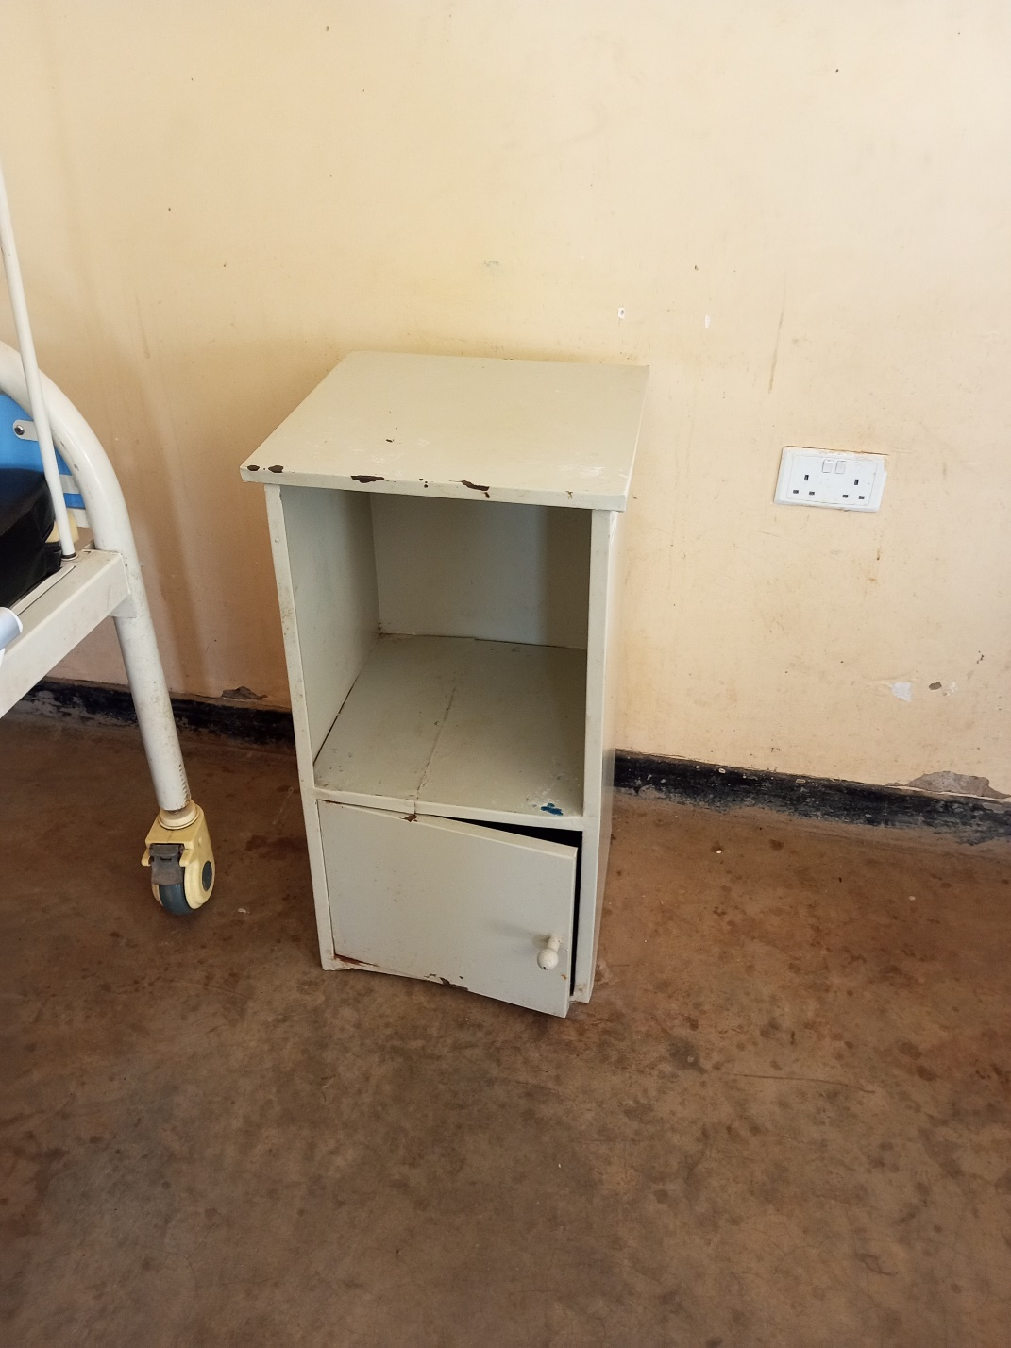

Filing Cabinet

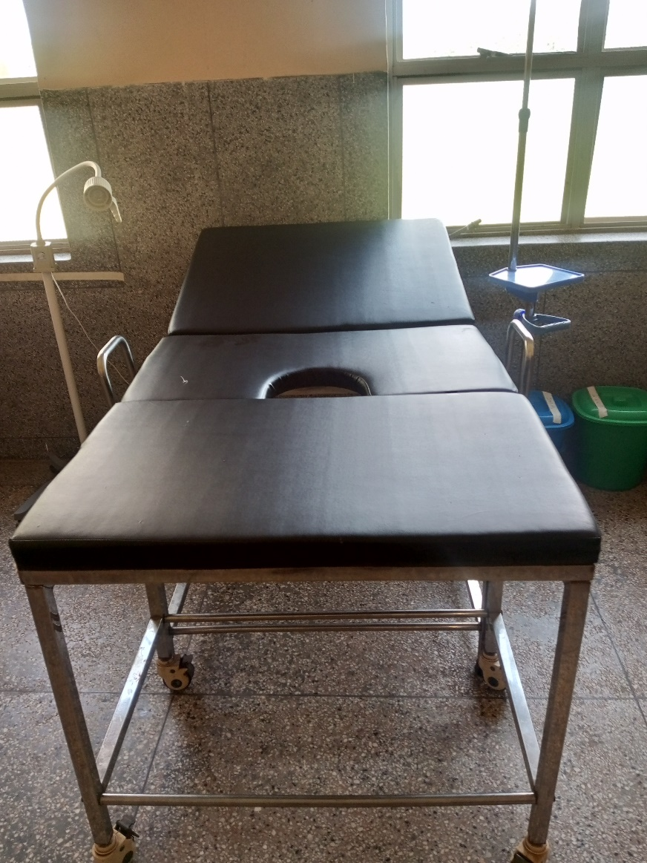

Delivery Bed

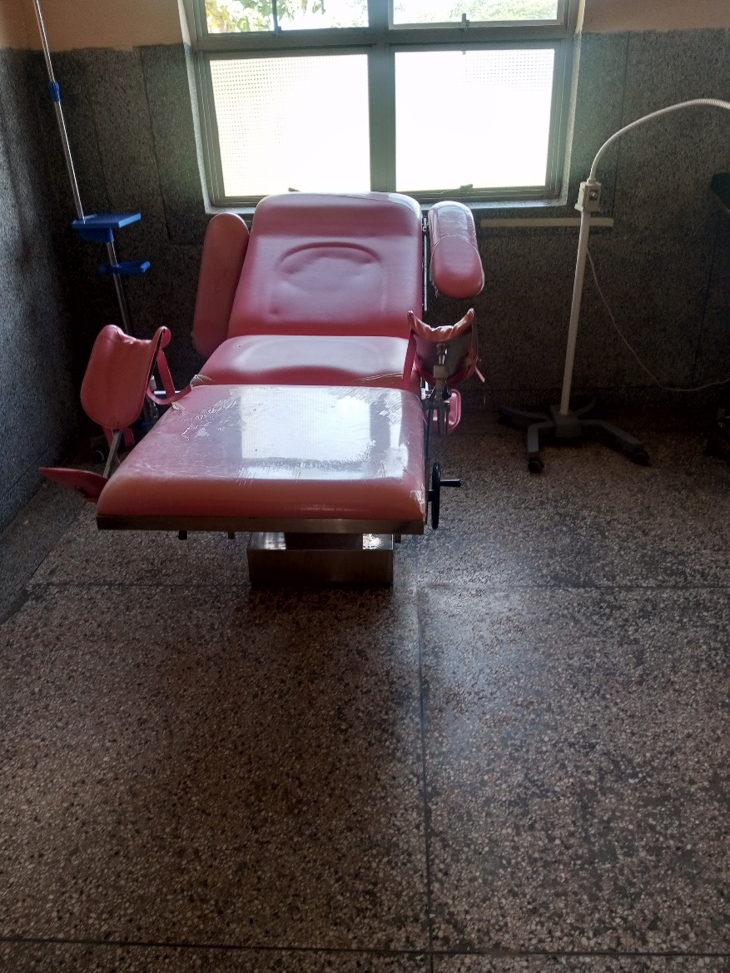

Delivery Bed Hydraulic Manual

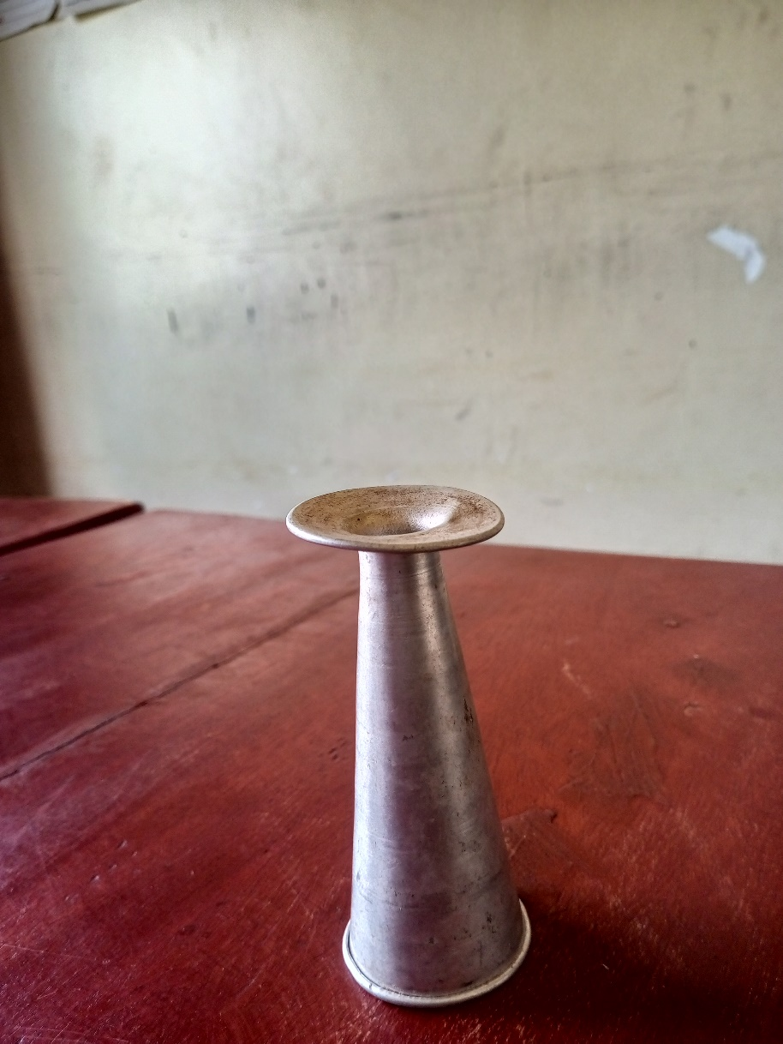

Feto scope

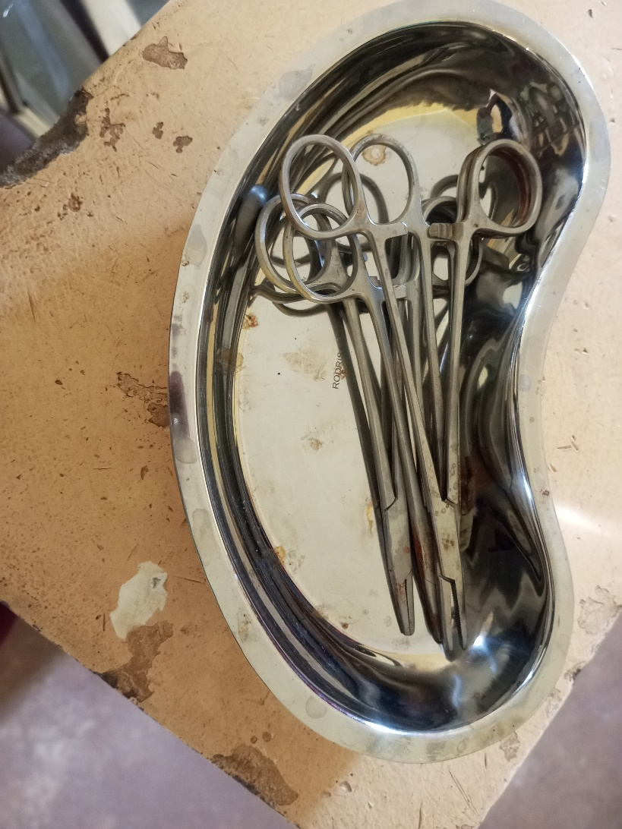

Equipment Set Stich Removal

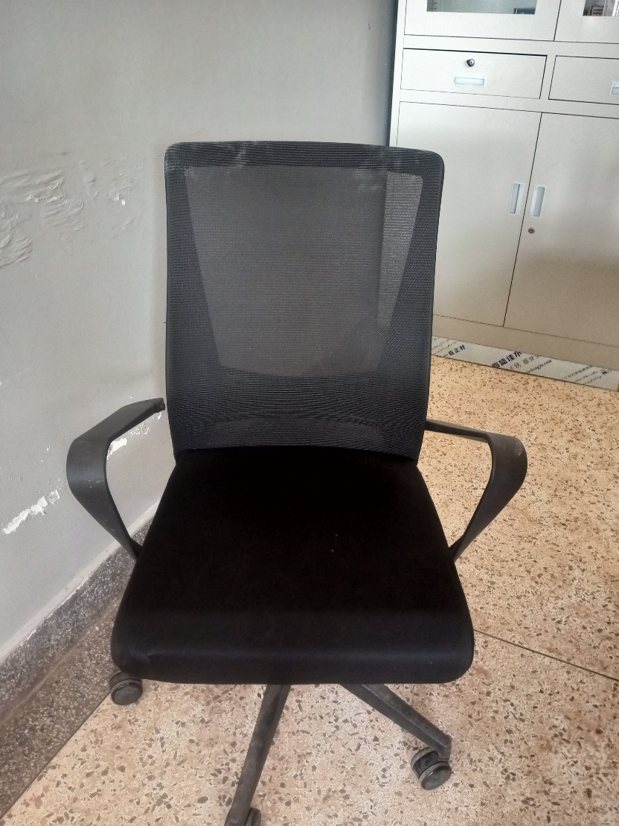

Office Chair

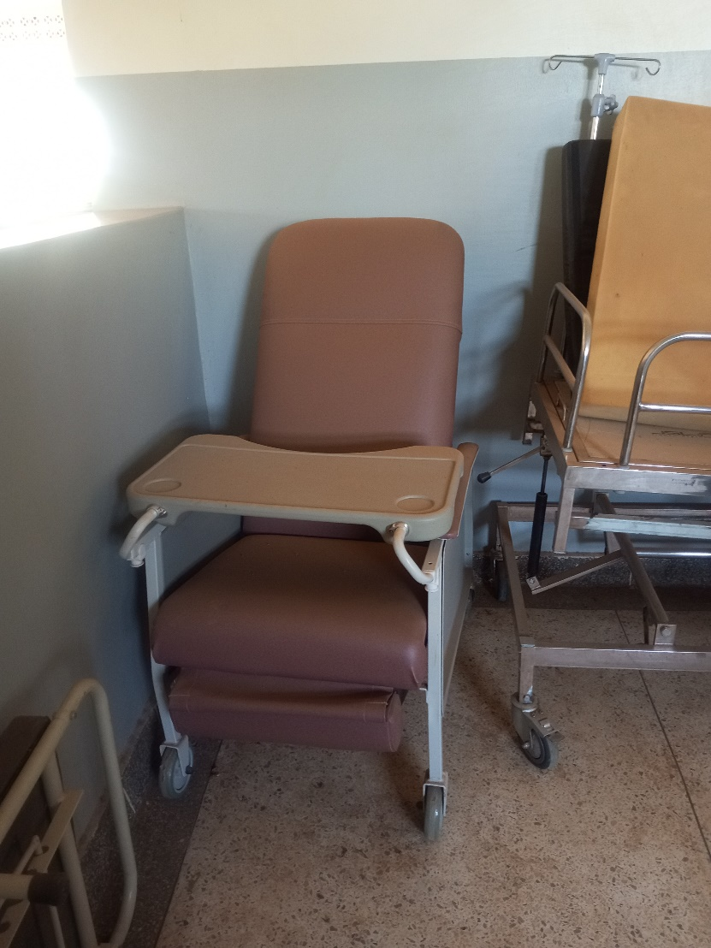

Kangaroo Mother Care Chair

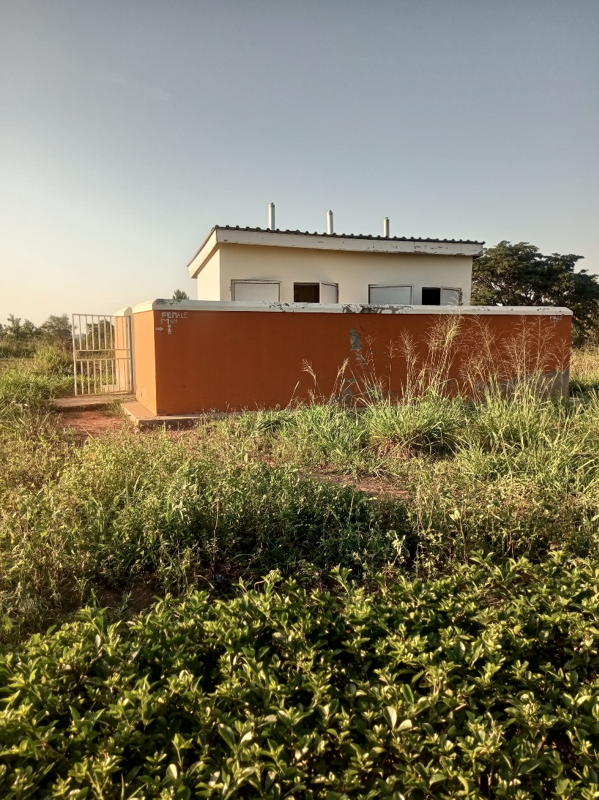

Awei H/C III Pit Latrine

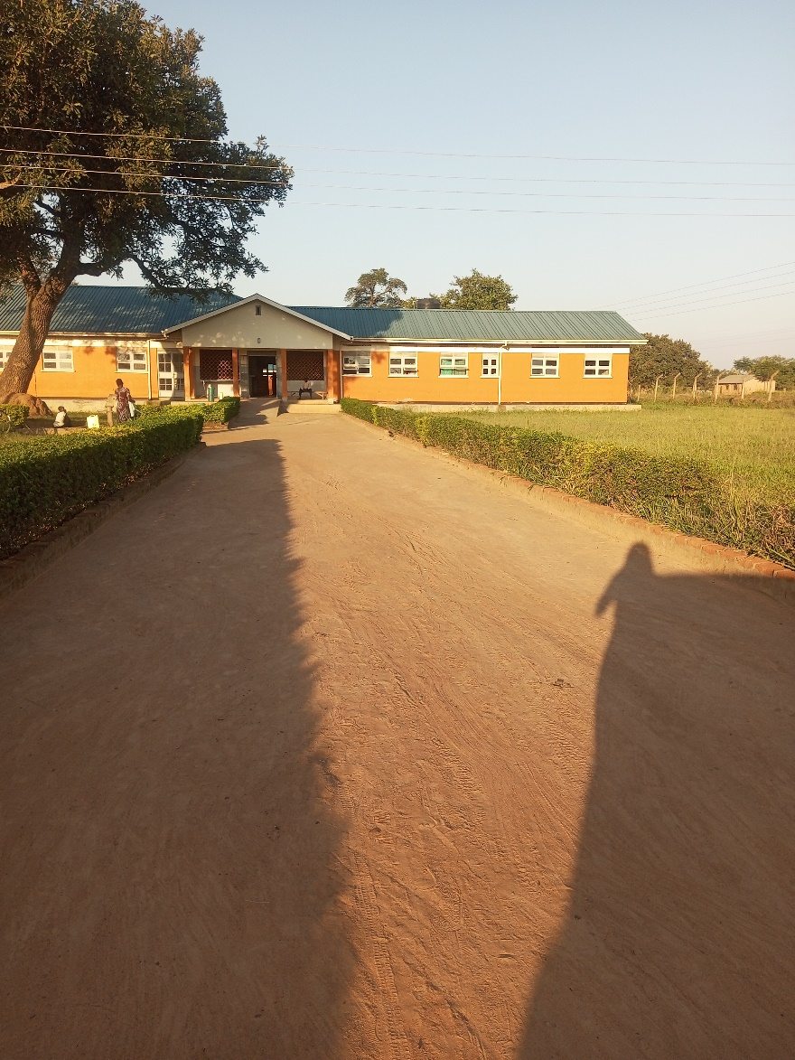

Awei H/C III MCH Ward

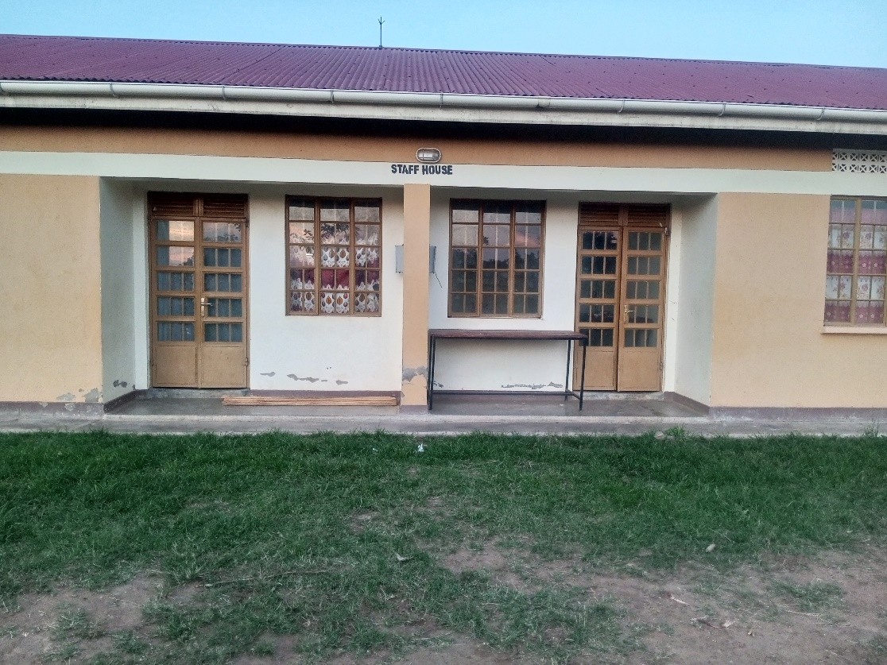

Awei H/C III Staff Twin House

